**Pre – Requisite to execute jar file:**

* Java version 1.8 must have installed on the system
* Latest Chrome browser version 57.0 must be installed on the system

**List Of files:**

* Jar file: contains main script
* Webdriver exe: Support file to run on the chrome browser
* Datafile: Excel file contains details of the attribute which needs to create(In some cases no need of Data file)
* Configuration property file: Some properties must be set before going to script execution.

**Instruction:**

* All the files stated above must be in the same folder
* Data file must in same format as provided with the script
* Data file must be in ‘.xlsx’ format

**Changes needs to be done in Config property file:**

**Common Variable:**

* **environment:** variable to set the environment on which this script needs to be run
  + **demo:** To run the script on ‘demo.aravo.com’ write value as below

**environment= demo**

* + **configuration:** To run the script on ‘configure.aravo.com’ write value as below.

**environment= configure**

* **user_type:** Set value for user_type to determine whether user is admin user or service firm user.
  + **admin:** To run script using admin user. (**user_type=admin)**
  + **configuration:** To run script with service firm or only configuration user (**user_type=configuration)**
* **username:** Enter username of the existing user
* **password:** Enter password of the entered user
* **organizationName:** Variable is used to select appropriate Client(Brand)
* **Organization name will come into the picture only when ‘admin’ user is there.**
* For example: On Demo environment.

**organizationName:** [**Aravo Professional Services Sandbox Service Firm**](https://demo.aravo.com/aems/session/changefiltertoken.do?organizationId=18060561&btnSetFilter=true&cs=J3TSiK0t5a7hRWMnxGboTbIb-fo8jTt_TGgU-KHhEQY.arv)

* **serviceFirm:** variable used to select service firm for configuration.

For example: On demo if we want to do configuration on IS **Trilok** then will mention service firm value as below:

**serviceFirm=IS Trilok**

* **excelfilename:** Name of the datafile from which you want to use the data

For Example: excelfilename= Attribute creation

* **excelsheetname:** Name of the sheet from specified excel file name from which you want to use the data

For example: excelsheetname = Sheet1

**How to run Jar file?**

* Method-1(Recommended):
  + - Open ‘Command prompt’ and go to the path where jar file resides
    - Write ‘**java -jar filename.jar**’ and press enter

Benefit: This method will show you the list of outputs/ error if any.

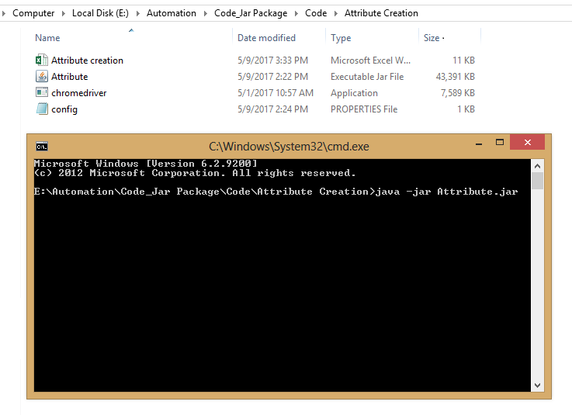

* Method -2:
  + - Double click on jar file